6. Temporary modulation for exercise and lighter (in-)activityV 3.6

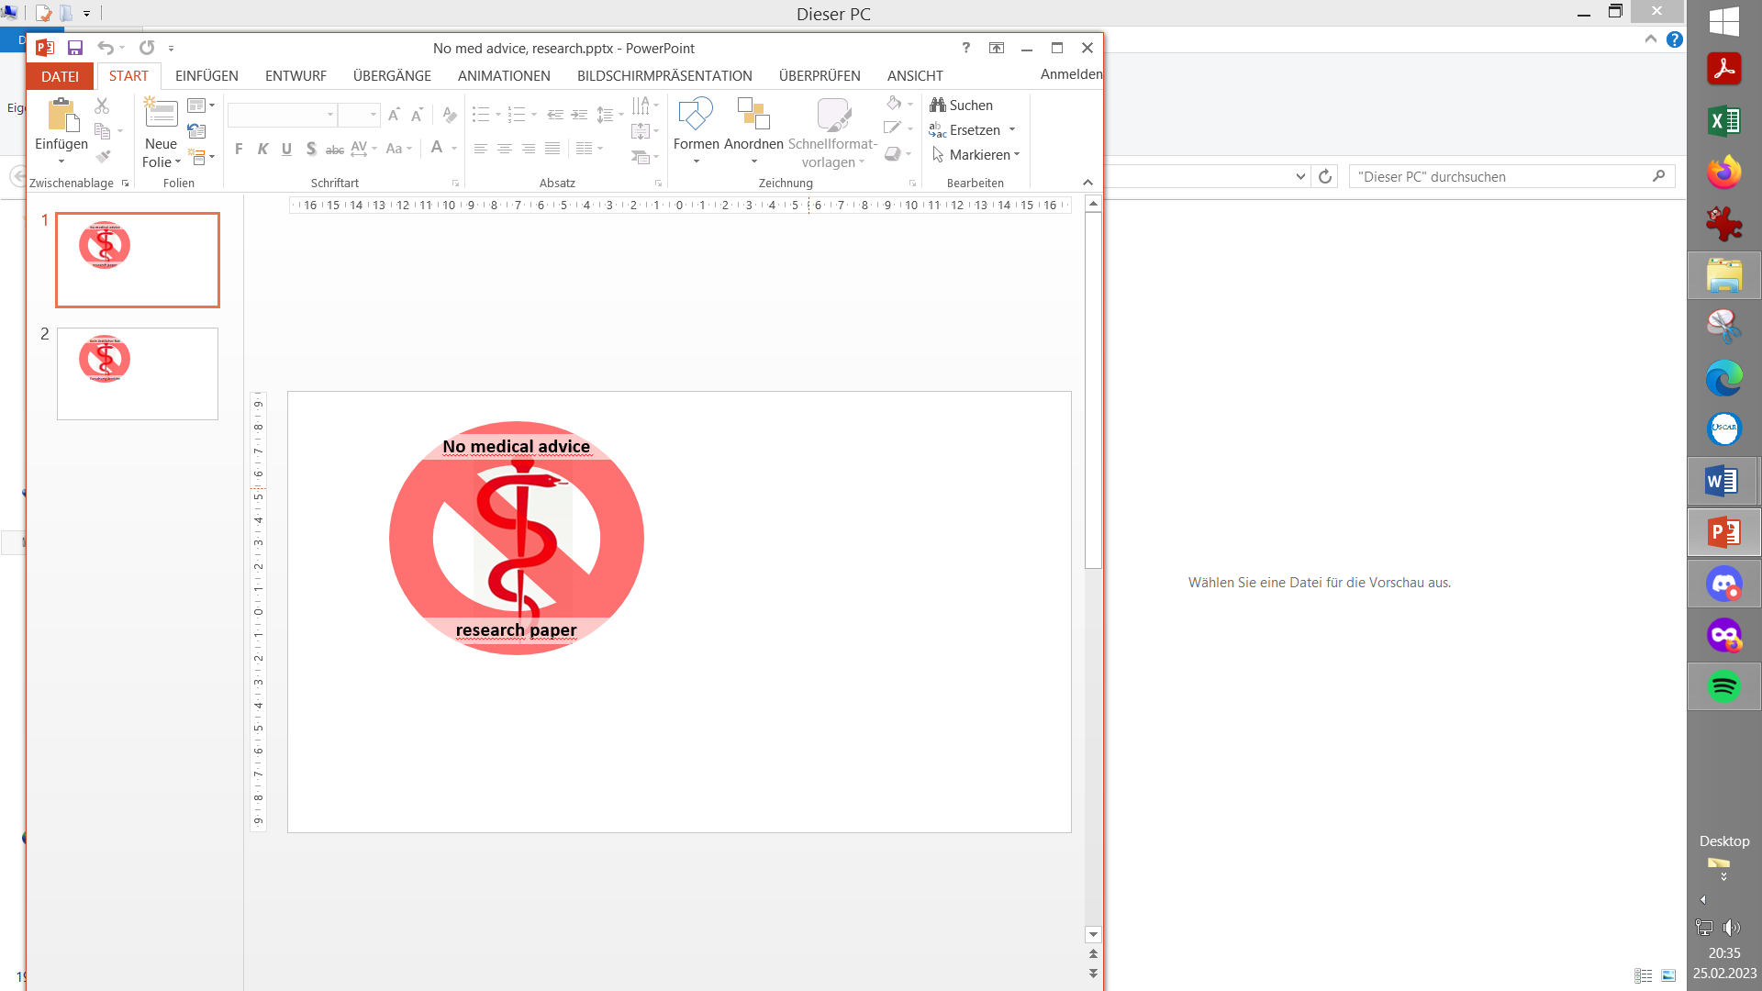

**Please note that with autoISF you are in an early-dev. environment**, where the user interface is **not optimized for safety** of users who stray away from intended ways to use.Good safety features exist, but these are only as good as the development-oriented user understands and implements them. This is not a medical product, refer to disclaimer in section 0

**6.1 Dynamic iobTH and sensitivity ratio**

Available related case studies:

Case study 6.2: Biking day with hi carb lunch; …………………… …DIY cockpit

6.1.1 Manual (direct) iobTH modulation

6.1.2 Automations for iobTH modulation

6.1.3 Dynamic iobTH

*Skip what is in* ***green writing***: = Drafted fragments or not implemented ideas.

Please contribute, or wait for update with the missing info

**6.2 Temp. % profile switch**

**6.3 DIY cockpit based on User action Automations**

**6.4 Improved FCL cockpit**

6.4.1 Manual (direct) iobTH modulation

6.4.2 pre-sets for 4 kinds of exercise

6.4.3 optional meal pre-sets

6.4.4 optional hypo management pre-sets

**6.5 Mastering the exercise after meal challenge**

6.5.1 Manual mode

6.5.2 DIY cockpit button for User action Automation

6.5.3 Laissez-faire mode

6.5.4 Using pre-sets in improved FCL cockpit

**6.6 Activity monitor based on step-counter**

Preliminary remarks

This section is **no easy read** because it attempts to describe *all options* to deal with *various types* of exercise.

* Fortunately, you might need *none* of them,
* you can set *any* of them up at your leisure, later, one at a time, for any of your occasional or regular exercise events,
* then pick one or two of the described options, how to go about it.

This is a **toolbox** and, in green, it sketches also *not yet developed* tools, so, unless you are deeply development interested, you can just skip over these green passages until a new product version is announced that may include aspects relevant to you.

* As long you were not able yet to define better ways, you should always be able to manage bg dropping during sports with **extra snacks** (keep those at hand).

Staying in contact with the related discord/github community should help greatly to find suitable ways to manage *your* type(s) of exercise.

* Please report *your* experience by supplying a case study.

Looking at case studies that relate to *your* kinds of exercise might be easier to digest than working your way through *all the options laid out* in this section.

For detail insights into how to manage **various kinds of exercise**, listen-in this reference by looping pioneer and sportswoman Dana Lewis: [https://bit.ly/DC1_631](https://bit.ly/DC1_631?fbclid=IwAR2u5t4jTTyjm_oVVFP3Vds2hKiDQXSj-Dk0SKWrt-y4VMm7xsBdkVp_Pqo_aem_AQ6bUgZMPwgog-5dpTW8LGFTYivdqghMD9hiKBMiDfE8gHPG1H7-R-I6pw2jri1A9ydaHz5_JWbKDdy5AUO00Wra) (starts around minute 05:30). Same is available through bit.ly/DiabetesCxnsAndroid or bit.ly/DiabetesCxnsApple

6.1 Dynamic iobTH and sensitivity ratio in „exercise mode“

iobTH is a iob threshold you can set, above which AAPS will no longer deliver additionalSMBs.

(This overrides the SMB management via even/odd bg target differentiation).

(Regarding by how much “*the last SMB*” may shoot over iobTH, see section 2.4).

**For exercise, we like to limit how high iob can go**, therefore automatic “dynamic” reduction of your set iobTH (= iobMAX x iobTH%) is a benefit, notably as you can individually tune it.

In autoISF 3.0 and later, a setting for iobTH is made in AAPS preferences, defined there as fraction (e.g. 0.6) of your set maxIOB:

/OpenAPS_SMB/autoISF_settings/Full_Loop_settings: iob_threshold_percent,

=> default iobTH = iobMAX x **iob_threshold_percent**

So, while iobTH could also be modulated via iobMAX, we mostly adapt the iob_threshold_percent to do that.

In the following, 3 principal avenues to temporary adjusting iobTH to your exercise requirements are described: ***Manual*** intervention (6.1.1), making use of individually defined Automations (6.1.2), and relying on the automatic dynamic adjustments coming with autoISF (6.1.3) .

The author experimented with all of them, but rarely needs manual intervention because the ***automatic “dynamic”*** adjustments work pretty well, after some individual tuning (see e.g. case study 6.2).

In any case it is good to educate yourself about manual tweaking options, should the need arise.

6.1.1 Manual (direct) iobTH modulation

„Manual“ routes to directly change iobTH would be

* changing the setting for the new parameter „iob_threshold_percent „
* or changing the setting for iobMAX

in /Preferences.

This is not a preferred route for temporary adjustment, because it is not easy accessible with just a button stroke, and it would not automatically revert to your prior setting, after use.

A future improved FCL cockpit (-> section 5.3) might give direct access to

* override iobTH temporarily, at any point of time.

A bridging solution that can achieve nearly the same is: to construct your own “DIY cockpit” button to change iobTH% from the AAPS main screen, see next section.

6.1.2 Automations for temporary iobTH modulation

You can define Automations that set a different iobTH% **under pre-defined conditions**

In a variation of this idea (if your Automation has the User Action box ticked), you get a grey button into your AAPS home screen, from which you can activate that changed iobTH manually (“DIY cockpit”, as was already presented in section 5.2.2.3)..

Note that this is the iobTH you tell the loop to use **in place of** the previously set iobTH:

* it will still be modulated further if %profile and TT are set (see below)
* it will overwrite the iobTH% you had set in /preferences!

**Caution**: A different iobTH% or bgAccel_ISF_weight can *not* be set *temporarily* in Automations (i.e. *a duration cannot be attached*). You **must** define a suitable **additional Automation that** must be active in tandem, that **restores the prior set iobTH%** or bgAccel-ISF_weight **again**. Else, once your Automation sets in, it will *forever* shift this important parameter setting!

If for instance you have several Automations that, in combination with a set elevated TT also set a lower iobTH: Don’t be fooled, the duration only applies to the TT. You need an extra Automation for all of them.

Example: My Automation that restores my prior set profile iobTH%: I picked out the *highest* of the *low*ered iobTH values that *other* Automations can set (45 percent was the highest “of the low ones” in my case), and then I can automatically restore to my *prior* 60% via this one:

**Caution:** Watch out for another potential stumbling block, because many Automations only work under the condition that no TT is already running.

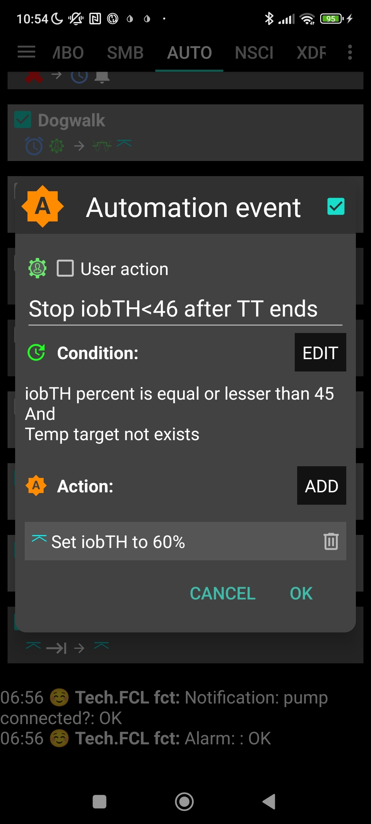

As temp. changing iobTH is quite tricky to automate, it is the author’s preferred route to only *indirectly* modify it – see next section.

6.1.3 Dynamic iobTH: iobTH modulation via setting a temp. glucose target (TT)

In AAPS/Preferences, set “**High TT raises sensitivity** = TRUE”. Then, setting an **elevated** temporary glucose target (TT), decreases iobTH by the same factor as it increases sensitivity (as it “softens” ISF). Both measures decrease insulin the loop can give.

Likewise, In AAPS/Preferences, set “**Low TT lowers sensitivity** = TRUE”. Then, setting a **low** temporary glucose target (e.g. a EatingSoonTT of 74 mg/dl), elevates iobTH by the same factor as it also sharpens (lowers) the ISF. The loop can give more insulin.

6.1.3.1 How does automatic sensitivity and iobTH adaptation work in the exercise mode?

**When. *additionally*. the exercise button is ON (lit yellow), iobTH gets reduced *particularly* strong, and ISF is *particularly* weakened (as desired for exercise).** That effect is the stronger (**ISF gets the weaker, iobTH the lower**), **the lower you set the half-basal exercise target** for your exercise mode in AAPS/preferences/OpenAPS SMB:

The following table shows, for a profile target of 100 mg/dl, how the set …

* @ half_basal_exercise_target you set in AAPS/preferences/OpenAPS SMB…

Choose a low number if you later want a high dynamic range of sensitivity modulation Lower half-basal exercise target = lesser insulin delivered

* … and @ your current exercise TT that you set on the day you do the respective exercise, with an eye on how you wish sensitivity auto-adjusted…

Higher TT = lesser insulin delivered

… determine the effective sensitivity ratio.

|  |  |  |  |
| --- | --- | --- | --- |
| Half basal ex.target | 180 | 150 | 120 |
| TT | sens.ratio | sens.ratio | sens.ratio |
| 100  100 = profile target | 1 | 1 | 1 |
| 120 | 0,8 | 0,71 | 0,5 |
| 140 | 0,67 | 0,56 | 0,33 |
| 160 | 0,57 | 0,45 | 0,25 |
| 180 | 0,50 | 0,38 | 0,20 |

The exact calculation for *any* combination of profile target, set TT, and half-basal_exercise_target is given in section 3.3

Note that:

* **temp. basal = profile basal * sens.ratio**

*Example:* At a half-basal_exercise_target *of 120,* setting a TT *of 120* gives only half (0.5) of profile basal (hence the name of the parameter)

* **temp.ISF = profile ISF / sens.ratio**
* **temp.iobTH = set iobTH * sens.ratio**

Whereas in “vanilla” AAPS the sens ratio is simply coming from you (manually) or Autosens (automatically) setting a temporary profile sensitivity other than 100% (and in the special case of dynamicISF with additional effects on ISF), here in autoISF we have strong, non-linear, and user scaleable effects on the sens.ratio.

6.1.3.2 How you recognize the real-time iobTH, and “aggressiveness” status of your FCL loop in general

Rather than bothering with the math, you can just look into your **SMB tab** where your selected temporary settings put your iobTH , and the modified ISF (called **sens**):

Same, with (via top left button in AAPS home screen) *additionally* ***70% profile*** applied:

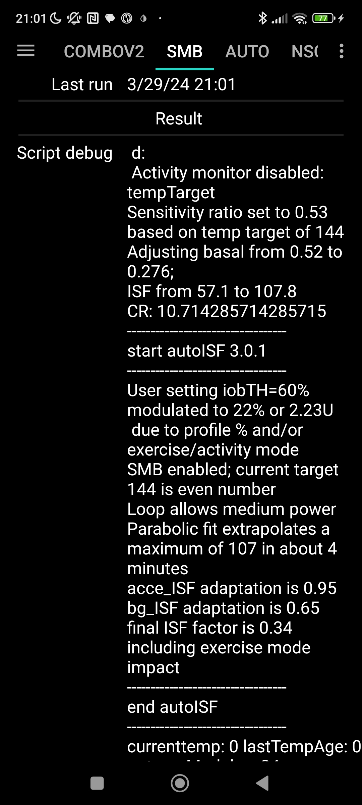

The valid “effective iobTH” can also be seen in the SMB tab, see example (for a **TT=144** and exercise button clicked);

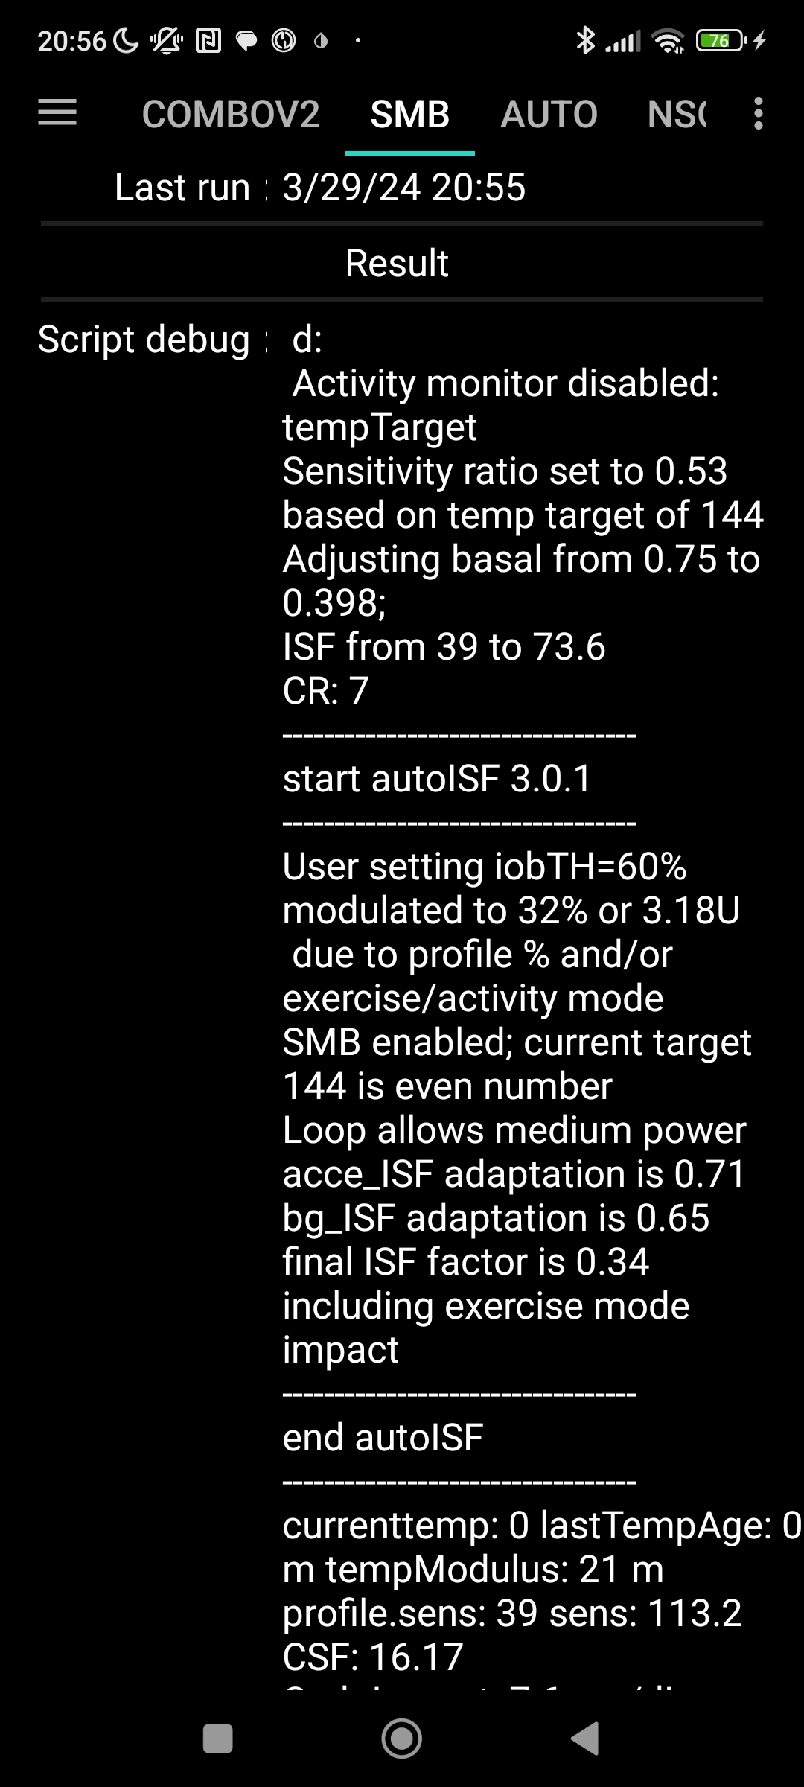

0.75 profile basal **\* 70%** = 0.52 temp.profile basal

39 profile ISF / **70%**

= 57 temp profile ISF

0.52\***0.53**=

0.75 \***0.53** =

=57 / **0.53**

=39 / **0.53**

= 60%\***0.53**\***70%**

60% \***0.53** =

=39 / **0.34** 0.340.340.340,340.53

profile.sens 39 sens: 162 = 39 / (**0.34** * 70%)

These examples show that, **by just setting an exercise TT and a typical exercise profile%** (two super easy “interventions” via the top buttons on our AAPS main screen, turning yellow in response as an easy “reminder” we are in a special mode)**, the iobTH will be automatically very sharply reduced** (in our example, to about half just by the TT; and further to about 1/3, by the % setting)

From the figures given (left side), the user’s iobTH calculates to 6.0 U (= (60%/32%)*3,18U) which is 60% of iobMAX of 10.0 U. So, normally, autoISF FCL could give SMBs up to anywhere between 6.0 U and 7.2 U (=6.0 +20%; see section 2.4 at step 2.4: at bg>100, iob can run max. 20% over with “last” SMB). For doing exercise, this window shrinks now to 3.18 – 3.82 U (left) or, even to 2.23 – 2.77 U (right).

In conclusion, these easy-to-make settings (TT, %profile) automatically provide the same thing like would have been done in Hybrid Closed Loop, where a meal bolus of about 7 U would get cut down to 4 U or even to 3 U, depending on type of exercise.

If you concurrently use QPython 3L and the emulator on your Android phone (see section 11) you need not look into the SMB tab, but could see more details (~ for the last hour, plus all contributing …ISF_categories from autoISF), in tabular form, on your phone.

For i-Phone autoISF users, double clicking on “Statistics” also provides similar information (see section 11.3).

6.1.3.3 Customization and-tuning

Try to determine good settings for the kinds of exercise that you engage in:

Set your **half-basal exercise target** in /preferences that suits all of them…

* … in tandem with reasonable TTs that you like to use later, for each of your intended specific exercises
* Iterate through this a couple of times (whenever you happen to do *that* exercise).
* **Remember** (“code” for yourself), **which TT stands for which exercise type, so that just by setting *that* TT everything (ISF, iobTH) *automatically* will provide the lower loop aggressiveness that you need for that specific type of exercise**.

When setting a TT please watch out for unintended implications and side-effects:

1. Setting a TT often **shuts out** **other** Automations. Therefore, choose the **duration** wisely (and also the **sequence**, in which all your Automations are listed).

(2) You always must consciously decide whether you set an **even or** an **odd** numbered bg **target** (TT or profile target). (This is assuming you use, as you should, the even/odd bg target differentiation for SMB on/off).

* Pick **odd,** if you do not want SMBs during exercise. (Despite your softened ISF, and lowered iobTH, SMBs still might „attack“ a sports snack too strongly).
  + However, odd cannot be set too early, when your meal digestion still requires SMBs.
  + Likewise, you might want the option for a few automatically delivered SMBs against unforeseen spikes (e.g. from excitement) also later. In that case, an **Automation** might **sneak in a desired SMB** or two via switching from odd to even, just for a couple of minutes, and under a well thought-out set of conditions (that you must find in **your** data patterns, when you do that kind of exercise that you try to find good settings for),

However, you are probably out of luck because an already set odd (or any) TT would preclude such Automation from kicking in. Then you need to **develop additional** ideas, another detour, like to first define an **Automation that briefly shuts your odd TT down**.

* + So, defining everything so you really can be happy with oddTT being your prímary way is a quite tricky project you should not under-estimate.
* Working with an **even** TT can be preferable, notably of course if your exercise is one that can get you totally excited, with glucose spikes.
  + While this mode generally does allow SMBs, the loop softens the ISF (by the sens.factor like in the table given above), and will temp. shut SMBs down, when **iobTH** (which also got lowered by the sens. factor) is exceeded.

Whether odd or even TT is better depends on the kinds of exercise you are doing, and probably depends on the protein and fat load of your meal and snacks, as well.

(3) **Timing** can be **critical** as to when you do your exercise announcement, especially relative to a preceding hi-carb meal. Then you want the reduced iobTH in place latest after you received the first SMB. See section 6.4 and case study 6.2

(4) Once you are familiar with the **dynamic range of *your* iobTH,**

* after you made your settings, notably set your half-basal exercise target
* knowing the range of TTs and %profile adaptations that you intend to use before/during/after your types of exercise

please confirm or re-consider *your***iobTH_percent setting in /Preferences,** section 2.4**.**

(5) You always can **look the effective iobTH up in the SMB tab** (see screenshots given 3 pages earlier).

In future releases you might see the valid iobTH that your loop is working with also in your AAPS home screen, next to the current iob status.

6.1.4 Tweaking iobTH

You can use any of the above discussed methods, or also the one that now follows in section 6.2, to *further tweak* iobTH temporarily, should you see a need.

Also outside of exercise,setting an ***even* elevated TT plus** pressing the **exercise button** gives easy access **to significantly reduce aggressiveness of your autoISF loop** via a resulting lowered iobTH and, concurrently, elevated effective ISF.

This could be used for instance for 45-60 minutes **at low/medium carb snacks**, as an alternative to shutting SMBs **entirely** off via an ***odd*** TT.

When *exercise follows a meal*, it might be smart to use the just discussed tweaking methods right after you felt the sting from the first big Lyumjev SMB. However, we will look at smarter and safer ways for this “exercise after meal” scenario in section 6.5 and in case study 6.2

6.2 Temporary % profile switch

A complementary measure you can take from the AAPS home screen is to set a **reduced temp.% profile** sensitivity.

This setting would **multiply** with the results in above table and further **reduce basal and iobTH** (whenever exercise button AND profile button both are yellow).

An example was already given with the 2nd screenshot, 3 pages earlier

Note that temp. reduction of basal will proportionally also **reduce the *max. allowed* size of SMBs** (which is two hours worth of basal x SMB_range_extention, see section 2.1)

The **time windows** for doing a profile switch *can differ* from the time window (duration) of your TT-related exercise settings. **Using all available tools then allows a nearly surgical approach to what you want to achieve for and during your favorite exercise(s).**

* Often the %profile modulation is used for several hours if not days to accommodate “long waved” sensitivity swings (See e.g. in case study 6.2).
* Instead, or even additionally, the percentage might be modified for just a couple of minutes, or for one special snack or meal duration, to “nudge” the proportionally modulated aggressiveness of the FCL (see section 5.2.3).

You can prepare yourself for anything you see coming up, or potentially coming up, in your daily life, so, from the comfort of your cockpit (section 6.3; section 6.5.2) you get ready for it within just a second or two, doing a few „clicks“.

6.3 Managing exercise via Cockpit inputs

*You may want to skip reading the green texts which are about suggested further features in future software updates*

6.3.1 Basic Settings for Exercise

Coming from FCL with no TT set (both top fields, TT and exercise, are grey), you best prepare for an intended exercise by **pressing the TT field** of your AAPS main screen (your looping cockpit; presented in section 5.2).

There, you can **freely select** TT and duration.

Alternatively, you can press on **one of 4 offered** exercise **presets**.(Note: This, and many other – in this green color - described cockpit features are yet to be developed)

When you do either one, the exercise button in the top middle of your AAPS main screen should turn yellow (or just press on the exercise button, when a TT is set.)

6.3.2 „Dynamic“ exercise mode off = traditional AAPS exercise mode (YGY)

When the dynamic exercise mode is off, you still have the instruments for *exercise management just as you always had it in the past* = a combination of manually softened aggressiveness via setting a temp. %profile change, and orienting corrections towards an elevated TT.

By selecting an odd numbered TT you now have the *additional option* to shut SMBs temporarily off, too.

***Continue with*** *section 6.5 – The following green texts (and embedded screenshots) describe currently not available features that were suggested for further development*

*If improved cockpit is launched,* the top part of the dialogue box looks about like this when the exercise field is grey:

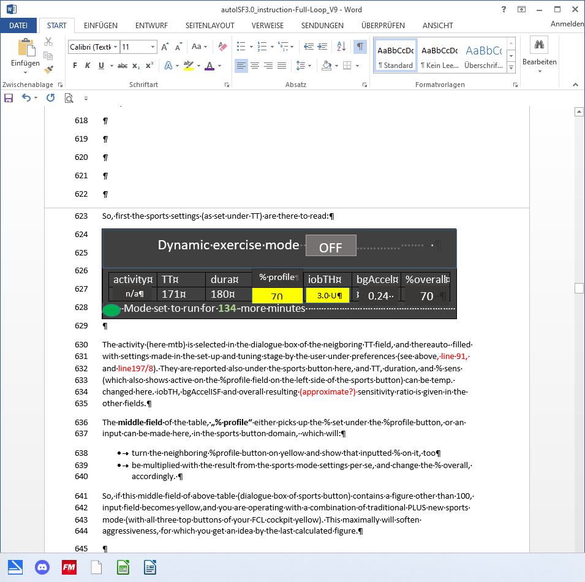

effect.sens.

**70 %**

% profile can be changed:

* either here => neighboring %profile button turns yellow too (with the % info on it); or
* under the %profile button; or
* it had already been changed using AAPS / Action / Profile switch

In all 3 cases, you see the number < 100 or >100 in the middle of above table, on a yellow colored field, too.

In this “YGY” mode, the % temp. set profile is the applied “effective sensitivity” (% ratio)

TT and duration can be entered or changed (= traditional mode to set exercise targets).

If there is a desire to try, for the **remaining duration,** a different iobTH or bgAccel_ISF-weight, this can be overridden in the table; field turns yellow, and the algorithm uses temp. iobTH and/or temp bgAccel_ISF_weight as modified in the exercise button (and reports this also in the SMB tab).

*In the dialogue box pictured above, 70% profile was set for 3 hours, and the default iobTH of 60% * 10 U was cut by 50% down to 3.0 U.*

The remaining duration shows below the table (*in the example: 134 minutes* and counting down).

The effective iobTH is given in the SMB tab. In later versions, the effective iobTH should show also in the AAPS home screen, next to the actual iob (*e.g. „1.2 U* ***<*** *3.0 U“)*

TT and % profile will also show on the yellow labels of the neighboring %profile (left top of AAPS home screen) and TT (right side), respectively.

The middle (exercise) field remains grey because the automatic sensitivity tuning (that would use TT and half-basal exercise target) are off.

6.3.3 Dynamic exercise mode ON (GYY or YYY)

By pressing the yellow exercise button on the AAPS home screen, *you have the option* to switch the **dynamic exercise mode ON**,in which case the middle field/exercise button of your AAPS main screen will go from grey to yellow.

In a version update you could do your setting for the upcoming exercise under the **dialogue box of the TT button**

Then, when you look into the exercise button in the middle of your FCL cockpit the dynamic exercise mode will automatically be „ON“, and all entries made:

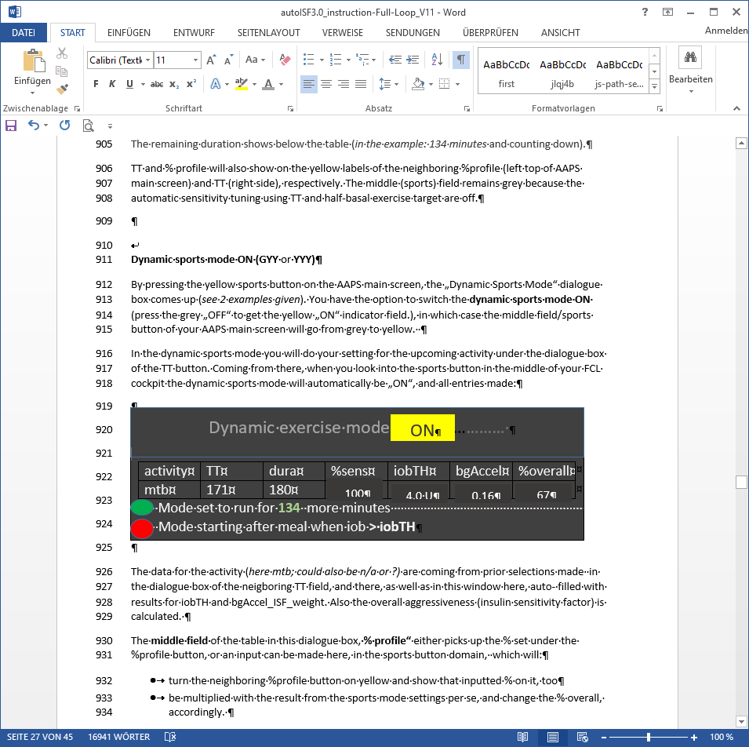

effect.sens.

**67 %**

The data for the kind of exercise (*here mtb; could also be n/a or ?)* are coming from prior selections made in the dialogue box of the neigboring TT field. There, as well as in this window here, the resulting iobTH and bgAccel_ISF_weight are shown. Also the overall aggressiveness (% overall insulin sensitivity factor) is calculated.

The **middle field** of the table in this dialogue box, **% profile“** either picks up the % set under the %profile button, or an input can be made here, in the exercise button domain, which will:

* turn the neighboring %profile button on yellow and show that inputted % on it, too
* be multiplied with the result from the exercise mode settings per se, and change the effective sensitivity %, accordingly.

So, if this middle field of above table (dialogue box of exercise button) contains a figure other than 100, the input field becomes yellow, and you are operating with a combination of traditional PLUS new exercise mode (with all three top buttons of your FCL cockpit yellow). This maximally will soften aggressiveness, for which you get an idea by the last calculated figure.

The mode is either running already (*for another 134 of the total 180 minute in the picture*) as also the label on the neighboring yellow TT field will show *171 (134, and counting down)*,

Or (*see at the red dot in picture above*), it is scheduled to run, after insulination for a started meal surpasses iobTH (*as in table*).

Note that, when the TT expires or is changed, your overriding input (if you made any) is automatically erased, forgotten.

6.3.4 Dynamic exercise mode ON plus %profile change (YYY)

The **middle field** of the table in the dynamic exercise mode dialogue box (see above), **% profile“** either picks up the % set under the %profile button, or an input can be made here, in the exercise button domain, which will:

* turn the neighboring %profile button on yellow and show that inputted % on it, too
* be multiplied with the result from the exercise mode settings per se, and change the % overall, accordingly.

So, if this middle field of above table (dialogue box of exercise button) contains a figure other than 100, input field becomes yellow, and you are operating with a combination of traditional plus new exercise mode (with **all three top buttons** of your FCL cockpit **yellow**). This **maximally will soften aggressiveness**, for which you get an idea by the last calculated figure.

Maximal softening happens only **when >100% profile**. A <100% profile is not used for exercise typically, and would counter-act the softening from the elevated TT.

It is advisable to find good settings primarily *within* the dynamic exercise mode. Use profile switches only complementary as needed. notably to provide for other, „longer waved“, health or hormonal situations.

Note that you can make use of the **exercise button** at any time for easy tweaking..

* yellow -> off/grey = increase

( only possible if a TT> 100 mg/dl is set )

* grey -> on/yellow = decrease

..the aggressiveness, without changing (and changing back) settings.

6.4 Option to pre-set for 4 kinds of exercise or meals(for 1 button operation)

*You may want to skip the entire section 6.4 because (green texts) mostly it is about non-existing further features, suggested for future software updates*

*Skip what is in* ***green writing***: = Drafted fragments or not implemented ideas.

Please contribute, or wait for update with the missing info

6.4.1 iob_threshold_percent

In AAPS preferences/OpenAPS SMB/autoISF settings / Full Loop Settings, the default iob_threshold_percent used for the normal meal spectrum is defined.

In an updated later autoISF version you might be able to diffentiate there for up to 4 meal clusters (see next section)

6.4.2 Pre-settings for (up to) 4 kinds of exercise:

In AAPS preferences/OpenAPS SMB/autoISF settings / Full Loop Settings: follows next input fields for pre-settings you can define for (up to) 4 kinds of exercise:

The following table gives an example of settings you may find well-suited for 4 of your favourite exercises

|  |  |  |  |  |  |  |  |
| --- | --- | --- | --- | --- | --- | --- | --- |
| #1-4 | give name (max 3 characters) | duration for TT ( (min) | TT (AC) (mg/dl) | % profile | iobTH | bgAcce:weight | Approx % ins reduct. |
| 1 | wlk | 60 | 111 | 100 |  |  |  |
| 2 | grd | 120 | 131 | 90 |  |  |  |
| 3 | bik | 300 | 151 | 90 |  |  |  |
| 4 | mtb | 180 | 171 | 70 |  |  |  |

Input fields (during tuning phase to determine good settings) are only the columns 2-5. The last 3 columns will be calculated from TT and %profile inputs, using also the half-basal exercise target and the default weight setting. In this setting.

The last is only an approximation to get a feel for a reasonable setting of the other parameters.

Here in preferences they should never be overridden, but TT or % profile should be adjusted to reach desired result when tuning for FCL.

Likewise, you find tables to make pre-settings for meals and for hypo treatments:

6.4.3 Pre-settings for (up to) 4 kinds of meals:

In AAPS preferences/OpenAPS SMB/autoISF settings / **Full Loop Settings**: follows next: Input fields for pre-settings you can define for (up to) 4 kinds of meals. For instance:

|  |  |  |  |  |  |  |
| --- | --- | --- | --- | --- | --- | --- |
| TT# 1-4 | give name (3 letters) | TT (Eating Soon) (mg/dl)e | Duration for TT (min) | iobTH (0---130% and < iobMAX) | bgAcce factor 200…0% |  |
| 1 | hiC | 72 | 120 | 110 | 110 |  |
| 2 | loC | 74 | 180 | 67 | 67 |  |
| 3 | piz | 76 | 300 | 100 | 100 |  |
| 4 | snk | 78 | 60 | 100 | 50 |  |

Input fields (during tuning phase to determine good settings) are all columns

Difference in TT is fairly unimportant (unless you do not give a name and memorize the set TT number instead, for which meal type it codes.

Logic why not having a % profile column here: %profile switch should be set extra, potentially for another time period *(e.g. „reserved“ for periods of exercise, or for entire days of altered insulin sensitivity, for instance due to illness, fasting, extensive sports week.)*

6.4.4 Pre-settings for (up to) 4 kinds of Hypo treatment:

In AAPS preferences/OpenAPS SMB/autoISF settings / **Full Loop Settings**: follows next: Input fields for pre-settings you can define for (up to) 4 kinds of HYPO treatment. Example:

|  |  |  |  |  |  |
| --- | --- | --- | --- | --- | --- |
| TT (ES) (mg/dl) | give name (3 letters) | TT (AC) (mg/dl) | Duration for TT (AC) (min) | bgTH  (mg/dl) |  |
| 1 | Hy1 | 131 | 55 | none |  |
| 2 | Hy2 | 131 | 55 | 200 |  |
|  |  |  |  |  |  |
|  |  |  |  |  |  |

Input fields (during tuning phase to determine good settings) are all columns, 2-5.

Choosing an odd-numbered TT is recommended as it can shut-out SMBs (with the appropriate setting in preferences/Open APS SMB/autoISF settings/smb_delivery settings/“enable alternatiuve activation…“.

Those of us who tend to over-treat hypos may prefer to set Hy2 (unless for night snacks-> Hy1): Reverting to standard loop aggressiveness with SMBs after/if a certain bg level („threshold“, similar to our iobTH for meals) is surpassed, and we want our loop to react again with SMBs before the set duration expires.

6.5 Mastering Exercise after a Meal

In Hybrid Closed Loop, we gave less insulin at meals (a reduced bolus) before exercise.

Since we now get our meal insulin automatically from the loop, we would have to at least somehow tell it that exercise follows this time.

Simply setting an exercise profile *before* the meal would make our full closed loop too weak in the "treatment" of the first glucose rise. **What we want is, to get our** (already, compared to HCL, delayed) **meal insulin delivered as fast as possible by SMBs. It just should be capped at the desired iob reduction.**

6.5.1 Manual mode requires 2 user interventions

What we can do, is (1) **reduce** the **iobTH** (via the _% setting, *e.g. by one third).*

* *In the example we were using, this would mean to reduce by 2 U to iobTH* = 4U.*
* Do that estimate for your data, and think back how you did bolus reduction in hybrid closed loop before same exercise.
* Likewise, you can use your profile ISF, *e.g. 30 mg/dl/U* and „translate“ by how much ( 2U * 30 mg/dl/U = 60 mg/dl) this „pulls you away from going into a hypo“.
* Using your IC (e.g. 8g/U) you can also translate the iobTH reduction (2 U) into a „snack equivalent“ (*2U * 8 g/U = 16* g) that you „replace“ by thinking ahead and „budgeting“ for some exercise with your iobTH modulation.

In this senario, our loop delivers SMB insulin as fast as always, only that when the last SMB has passed the iobTH, the loop only has elevated %TBR to work with, meaning it cannot raise iob by much any longer. This provides an elevated glucose level on which we enter exercise, and saves us hypo danger or snack need (as calculated in above examples).

After this reduced iobTH is reached (or up to 30% exceeded by the last SMB, up to 20% @ even TT>100 mg/dl)), step (2) must follow = an increased exercise **bg target** is set (see section 6.2).

The problem with this approach is that it requires **two** user interventions, first **setting the lower iobTH**%, and later (**and** this ***in a time-critical manner***, after iobTH is exceeded), to **input an exercise TT,** or to activate a related setting.

To eliminate this problem, the following refined solutions are suggested:

6.5.2 DIY cockpit: Using pre-set meal / exercise settings from a User action Automation

The „DIY cockpit“ user interface allows a *one-step* setting for meal + exercise that can be selected in time-uncritical fashion, any time before the meal starts.

A detailed example is given in case study 6.2:

A sequence of 3 Automations must be set up, of which only the first one must be manually triggered, in just one time-uncritical key stroke from the AAPS home screen.

The others are activated automatically, when the respective Conditions are met.

Automation #1 provides, for a meal that precedes exercise, the full loop aggressiveness, but makes sure that this aggressiveness stops immediately after a (reduced) iobTH is exceeded. The reduced iobTH ensures that not too much insulin is on bord for exercise after the meal. Also it provides an elevated bg level at (re-)start of exercise.

In this Automation, the box “User action” should be permanently ticked. This will automatically provide a **grey button on the bottom of the AAPS home screen** (“DIY cockpit”) that can be freely named (= headline of Automation #1).

For exercise that is not done frequently, I choose to get rid of that cockpit button by disabling the Automation fully, in my list of Automations… until the evening before e.g. a bike tour, when I will want to have my cockpit give me the optional button again.(See case study 6.2)

When the reduced iobTH is exceeded, two things need to be provided :

1. a milder running FCL (reduced exercise %profile, after the meal rise had been managed based on 100% profile boosted further by bgAccel_ISF driven full loop aggressiveness) => Automation #2 sets e.g. 70% profile and ends TT
2. setting an exercise TT (not possible with Automation #2. But *after* it terminated the TT, an Automation #3 can immediately follow, and set the desired exercise TT=125 (which implies the exercise mode

Note that Automations 2 and 3 are fully automatic, no User action is involved. See case study 6.2 for an example

Should, during the exercise, a need arise to modulate the loop aggressiveness (iobTH, effective ISF), this can be done within 1-2 seconds, also right from the AAPS home screen („FCL cockpit“), by setting a higher or lower temp. %profile, and/or by setting a higher or lower temp. exerciseTT.

To make the loop temporarily act a bit more aggressive, switching the exercise button OFF (from yellow to grey) could also be considered

Defining User action - Automations to build your FCL cockpit

If you want to develop *your* **DIY User Interface**, make sure you define suitable settings that reflect ***your*** personal insulin sensitivity and data patterns.

**Caution:** As mentioned in other places, Automations can be tricky as to whether they actually will ever work, because the loop goes through the exact **sequence of all your active Automations**, and might be switched into a direction that no longer is compatible with the conditions that must be a given, for the Automation you think that should kick in.

To have a clean AAPS home screen (and also to prevent unnecessary/accidential activation by kids playing around with offered buttons), define reasonable time windows for each of your shelved special routines, or keep them entirely dormant (de-activated) in the list of all your Automations, and activate them only for/on the day when you think you might need them

6.5.3 Laissez-faire alternative

You couldmake your life easier: **Just use** (as in Hybrid Closed Loop) **an exercise setting** and accept a resulting reduced loop aggressiveness **already before meal start**. You would go a bit higher in your glucose peak. As, in principle, a higher glucose level is desirable for starting exercise, this can be a viable route, too, **especially if you do a** (often recommended) ***protein-rich* meal before exercise**.

Logic: For a high carb containing meal, we wanted in the preceding sections a strong initial FCL response, but only up to a certain (lowered) iob. (This resembles the reduced user bolus in HCL around exercise.). However, the more our meal shifts to high protein rather than high carb load, and the more we are accepting of bg going a bit higher before we start or resume our exercise, the better we can tolerate a FCL aggressiveness also at meal start, i.e. the entire day.

Continue with section 6.6

***Skip next*** *section 6.5.4 – The following green texts (and embedded screenshots) describe currently not available features that were suggested for further development*

6.5.4 Improved cockpit: Using pre-set meal / exercise combination from TT dialogue box

The improved „FCL cockpit“ User Interface (when available) also allows a one-step setting for meal + exercise that can be selected in time-uncritical fashion, any time before the meal starts.

It manages the meal with an appropriately reduced iobTH, and is programmed to automatically activate the exercise settings when iobTH is exceeded:

If in addition to meal, one of the 4 pre-programmed exercises is also selected from the bottom of the TT dialogue box, *(for example, in case of biking after a hi carb lunch, hiC + bik, see* section 5.3.3.1*.)* then meal gets superseded /overridden with condition „duration = until when iobTH is first time exceeded“. Plus, that is the other important point, the activity-related reduced iobTH is taken over for the meal, too.

All this happens from the AAPS home screen and associated dialogue box from the TT field there.

Actual valid settings can at any time point be seen in the AAPS home screen (see section 5.3.3.1 on extra data fields, above).

When your FCL is in this meal + exercise mode, you first see at the TT field (section 5.3.3.1) of your AAPS main screen:

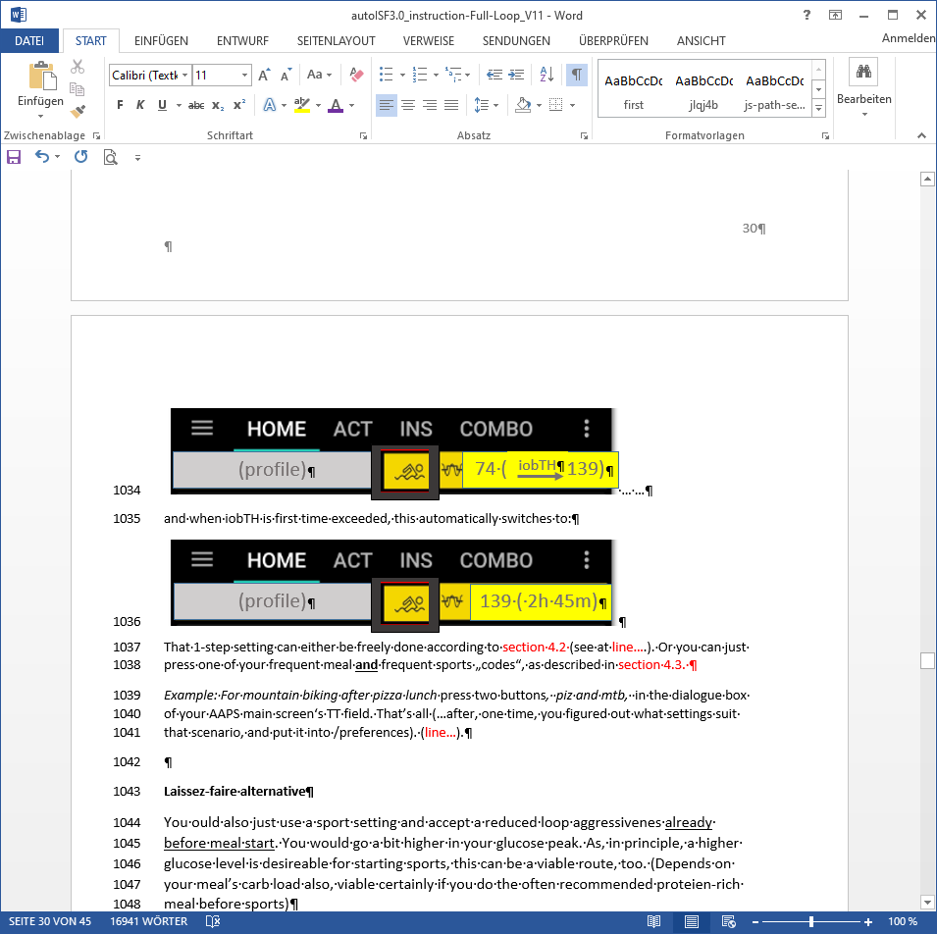

… and when iobTH is the first time exceeded, this automatically switches to:

That 1-step setting can either be freely done according to section 6.2

**Or** you can just press one of your frequent meal **and** frequent exercise „codes“, as described in sections 6.3.2 and 6.3.3

*Example: For mountain biking after pizza lunch* press two buttons*, piz and mtb,* in the dialogue box of your AAPS home screen‘s TT field. That’s all (…after, one time, you figured out what settings suit that scenario, and you put it into /preferences, see sections 6.3.2 and 6.3.3).

6.6 Activity Monitor

An optional feature for times without serious exercise, but still suspected **effects on insulin sensitivity** is the **activity monitor**.

It can be generally activated under /preferences/OpenAPS SMB/Activity modifies sensitivity)

If the user

* has scaling factors set there (in preferences/OpenAPS SMB/Activity modifies sensitivity)
* has **no TT running**
* (and, regarding nighttime: did not opt for „ignore_inactivity_overnight“)

then AAPS automatically modulates for sensitivity changes **based on movement intensity** for the last minutes to 1 hour time frame.

**Personalized tuning** of the **two scaling factors** is necessary *in your FCL set-up phase*. For details see section 3.4.

Later, *in your running FCL*, this **will automatically adjust insulin delivery** (basal, ISF, and iobTH; see 1st screen of AAPS SMB tab!)to suit activity state of the past minutes (up to 1 hour). See also section 5.1.5.Monitor)

Effects from the Activity Monitor are hard-limited to go **maximally**

* **plus 20%** insulin at detected resistance (in-sensitivity to insulin) **at in-activity**
* **minus 30%** insulin at detected increased sensitivity to insulin due to **activity.**

**Note that Activity Monitor only works when *no*** exercise (orother) **TT is active:**

* Whenever you set a TT, you consciously go for a certain effect on the sensitivity ratio to be used in that time window.

Usually it will be stronger than the tweaking that the Activity Monitor would do. But you would not want the Activity Monitor interfere, and additionally tweak things you just defined differently for a certain situation, and time window, by setting a TT.

* During the set TT, your Activity Monitor **keeps collecting** the data on your activity/in-activity. Immediately after the set TT ends, the Activity Monitor **automatically** **resumes** its work

This is good news also for those who might use brief even/odd target switches (e.g. when sneaking-in a small snack w/o triggering a SMB), but would hate to see their Activity Monitor function go under for a while afterwards.

You can easy, in real-time, check the impact of your Activity Monitor on the sensitivity used (to calculate your insulinRequired, or to auto-adjust also iobTH) in your AAPS **SMB tab**. From autoISF 3.0.1 onwards, this is super easy to retrieve in the 1st screen, on top of the autoISF results.

Idea for an eventual User Interface update for the Activity Monitor:

In this dialogue box (connected *in a future update* with the exercise button), the two scaling parameters (set as default by the user during initial set-up in preferences) are displayed, and can be temp. over written. (These settings will expire and revert to default as set in /preferences, whenever the Activity Monitor closes (goes auto-off, or is pushed off)).

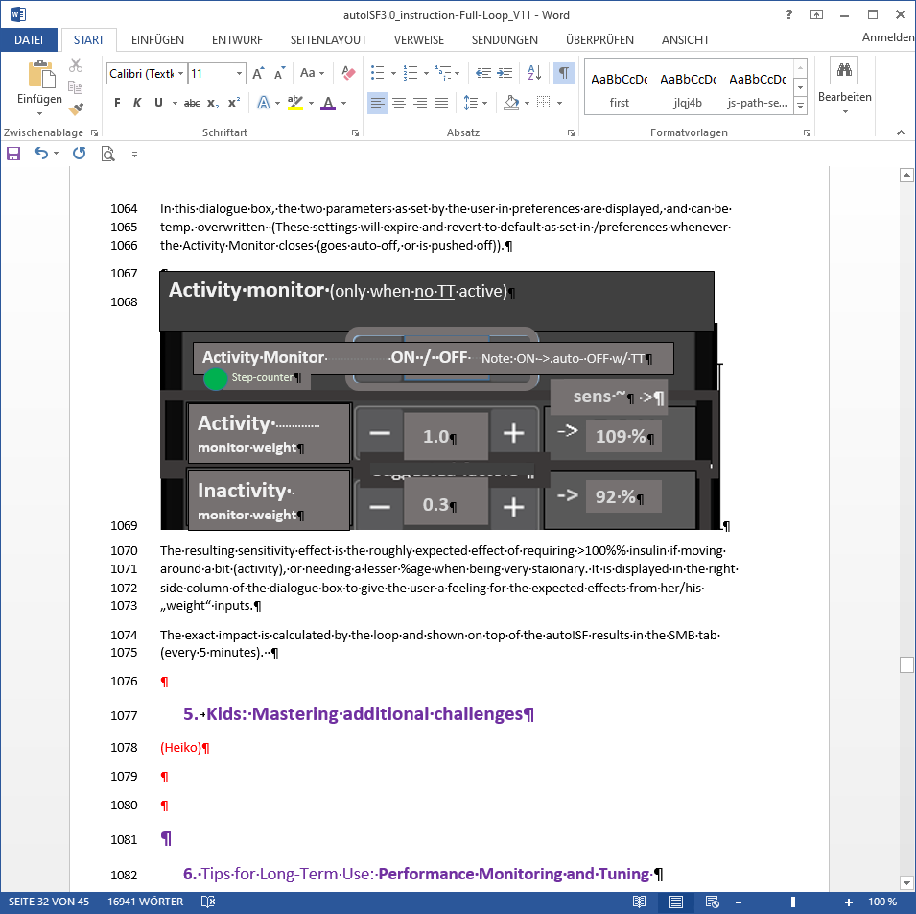

The resulting sensitivity effect is the roughly expected effect of requiring >100% insulin if moving around a bit (activity), or needing a lesser %age when being very stationary.

It is displayed in the right side column of the dialogue box *(if already launched)* to give the user a feeling for the expected effects from her/his „weight“ inputs.

The exact impact is calculated by the loop and shown on top of the autoISF results in the SMB tab (every 5 minutes).